MTA ASSIGNMENT: LOGIC UPGRADATION

PROGRAMS

***Name : AKASH GIRI***

***PROGRAM 1:***

Write A program to accept Four digit number from user and count zero , odd and even digits from the entered number.

***CODE:***

using System;

using System.Collections.Generic;

using System.Linq;

using System.Text;

using System.Threading.Tasks;

namespace Assignment1_1

{

class Program

{

static void Main(string[] args)

{

Console.Write("Enter a four digit number : ");

int n = Convert.ToInt32(Console.ReadLine());

int odd = 0, even = 0, zero = 0,x;

while (n>0)

{

x = n % 10;

if (x == 0)

zero++;

else

if (x % 2 == 0)

even++;

else

odd++;

n /= 10;

}

Console.WriteLine("Odd digits : " + odd + "\nEven digits : " + even + "\nZero digits : " + zero);

Console.ReadLine();

}

}

}

***OUTPUT:***

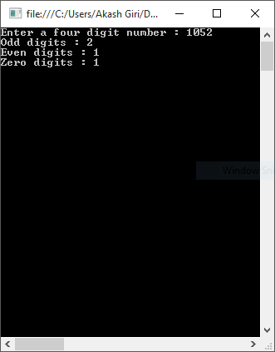

**_____________________________________________________________________________________**

***PROGRAM 2:***

Write a program to accept ‘n’ numbers from user , store these numbers into an array. Find out maximum and minimum number from an Array.

***CODE:***

using System;

using System.Collections.Generic;

using System.Linq;

using System.Text;

using System.Threading.Tasks;

namespace Assignment1_2

{

class Program

{

static void Main(string[] args)

{

Console.Write("Enter the length of arrey : ");

int n = Convert.ToInt32(Console.ReadLine());

int[] ar = new int[n];

int i,min,max;

for(i=0;i<n;i++)

{

Console.Write("Enter the element : ");

ar[i] = Convert.ToInt32(Console.ReadLine());

}

max = min = ar[0];

for (i = 0; i < n; i++)

{

if (max < ar[i])

max = ar[i];

if (min > ar[i])

min = ar[i];

}

Console.WriteLine("\nMaximuim element : " + max);

Console.WriteLine("Minimum element : " + min);

Console.ReadLine();

}

}

}

***OUTPUT:***

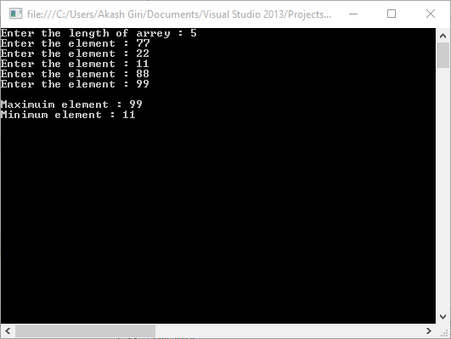

***PROGRAM 3:***

Write a menu driven program in that shows the working of a library. The menu option should be

--ADD BOOK INFORMATION

--DISPLAY BOOK INFORMATION

--LIST ALL BOOKS OF GIVEN AUTHOR

--LIST THE COUNT OF BOOKS IN THE LIBRARY

--EXIT

***CODE:***

using System;

using System.Collections.Generic;

using System.Linq;

using System.Text;

using System.Threading.Tasks;

namespace Assignment1_3

{

public class Books

{

public string Name, Author, ISBN;

public void Accept()

{

Console.Write("Enter ISBN number : ");

ISBN = Console.ReadLine();

Console.Write("Enter Name : ");

Name = Console.ReadLine();

Console.Write("Enter Author : ");

Author = Console.ReadLine();

}

public void Show()

{

Console.WriteLine("Book ISBN : "+ISBN);

Console.WriteLine("Book Name : " + Name);

Console.WriteLine("Book Author : " + Author+"\n");

}

}

class Program

{

static List<Books> l = new List<Books>();

static void Main(string[] args)

{

Console.WriteLine("Press 1 to Add Book Information");

Console.WriteLine("Press 2 to Display Book Information");

Console.WriteLine("Press 3 to Display Book Information by Given Author");

Console.WriteLine("Press 4 to Display the Count of Book");

Console.WriteLine("Press 5 Exit\n");

int ch;

do

{

Console.Write("Enter Your Choice : ");

ch = Convert.ToInt32(Console.ReadLine());

switch (ch)

{

case 1:

Books obj = new Books();

obj.Accept();

l.Add(obj);

Console.WriteLine("Book added successfully!!\n");

break;

case 2:

if (l.Count() == 0)

Console.WriteLine("Library is empty!!\n");

else

{

Console.WriteLine("Books in Library:\n");

foreach (Books b in l)

b.Show();

}

break;

case 3:

if (l.Count() == 0)

Console.WriteLine("Library is empty!!\n");

else

{

Console.Write("Enter the Book's Author :");

string auth = Console.ReadLine();

foreach (Books b in l)

{

if (b.Author == auth)

b.Show();

}

}

break;

case 4:

Console.WriteLine("Number of books is " + l.Count() + "\n");

break;

default:

Console.WriteLine("Ooopsss!! Invalid Input. Try again.");

break;

}

} while (ch != 5);

}

}

}

***OUTPUT:***

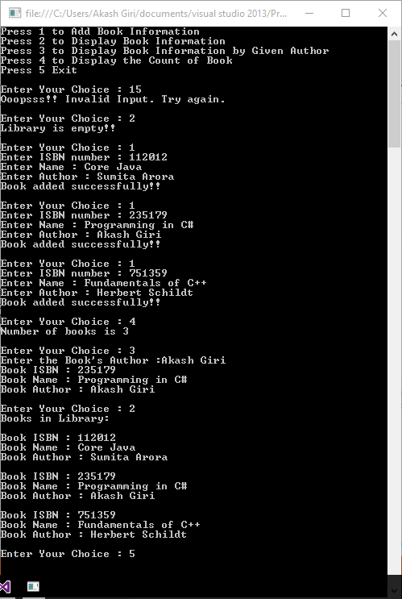

***PROGRAM 4*:**

Write a program to accept ‘n’ numbers from user , store these numbers into an array and sort the numbers of an array using function.

***CODE:***

using System;

using System.Collections.Generic;

using System.Linq;

using System.Text;

using System.Threading.Tasks;

namespace Assignment1_4

{

class Program

{

static void Main(string[] args)

{

Console.Write("Enter the length of array : ");

int n = Convert.ToInt32(Console.ReadLine());

int[] ar = new int[n];

int i, min, max;

for (i = 0; i < n; i++)

{

Console.Write("Enter the element : ");

ar[i] = Convert.ToInt32(Console.ReadLine());

}

new Program().sort(ar,n);

}

private void sort(int[] ar,int n)

{

int i, j,t;

for(i=0;i<n-1;i++)

{

for(j=0;j<n-i-1;j++)

{

if(ar[j]>ar[j+1])

{

t = ar[j];

ar[j] = ar[j + 1];

ar[j + 1] = t;

}

}

}

printArray(ar);

}

private void printArray(int[] ar)

{

Console.WriteLine("Sorted Array is :");

foreach(int x in ar)

{

Console.WriteLine(x);

}

Console.Read();

}

}

}

***OUTPUT:***

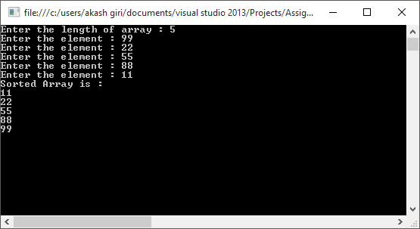

***____________________________________________________________________________________***

***PROGRAM 5:***

Write a program to accept customer details such as : Account_no, Name, Balance in Acount, Assume Maximum 20 Customer In the bank. Write a function to print the account no and name of each customer with balance below rs 100.

***CODE:***

using System;

using System.Collections.Generic;

using System.Linq;

using System.Text;

using System.Threading.Tasks;

namespace Assignment1_5

{

class Customer

{

public string name, num;

public double bal;

public void Accept()

{

Console.Write("Enter Name : ");

name = Console.ReadLine();

Console.Write("Enter A/C Number : ");

num = Console.ReadLine();

Console.Write("Enter Balance : ");

bal = Convert.ToDouble(Console.ReadLine());

}

}

class Program

{

static Customer[] ar = new Customer[20];

static void Main(string[] args)

{

int i,j=0;

for(i=0;i<20;i++)

{

Customer ob = new Customer();

ob.Accept();

if (ob.bal < 100.0)

ar[j++] = ob;

}

Console.WriteLine("Customers having balance below Rs. 100 are :");

foreach(Customer c in ar)

{

Console.WriteLine(c.name + "\t" + c.num);

}

Console.Read();

}

}

}

***OUTPUT:***

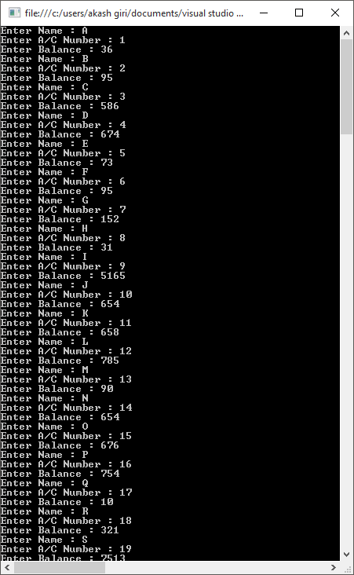

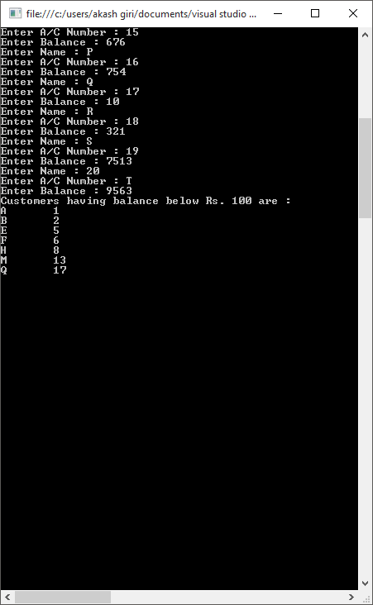

***_____________________________________________________________________________________***

***PROGRAM 6:***

Write a program to accept 5 names from user and store these names into an array sort these array element in alphabetical order.

***CODE:***

using System;

using System.Collections.Generic;

using System.Linq;

using System.Text;

using System.Threading.Tasks;

namespace Assignment1_6

{

class Program

{

static void Main(string[] args)

{

Console.Write("Enter the length of array : ");

int n = Convert.ToInt32(Console.ReadLine());

string[] ar = new string[n];

int i, min, max;

for (i = 0; i < n; i++)

{

Console.Write("Enter the element : ");

ar[i] = Console.ReadLine();

}

new Program().sort(ar, n);

}

private void sort(string[] ar, int n)

{

int i, j;

string t;

for (i = 0; i < n - 1; i++)

{

for (j = 0; j < n - i - 1; j++)

{

if (ar[j].CompareTo(ar[j + 1])>0)

{

t = ar[j];

ar[j] = ar[j + 1];

ar[j + 1] = t;

}

}

}

printArray(ar);

}

private void printArray(string[] ar)

{

Console.WriteLine("Sorted Array is :");

foreach (string x in ar)

{

Console.WriteLine(x);

}

Console.Read();

}

}

}

***OUTPUT:***

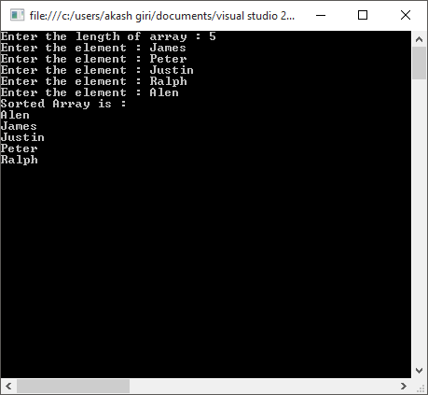

***_____________________________________________________________________________________***

***PROGRAM 7:***

Write a program to calculate the sum of digits of a given number.

***CODE:***

using System;

using System.Collections.Generic;

using System.Linq;

using System.Text;

using System.Threading.Tasks;

namespace Assignment1_7

{

class Program

{

static void Main(string[] args)

{

Console.Write("Enter a four digit number : ");

int n = Convert.ToInt32(Console.ReadLine());

int sum = 0,x;

while (n > 0)

{

x = n % 10;

sum += x;

n /= 10;

}

Console.WriteLine("Sum of digits = "+sum );

Console.ReadLine();

}

}

}

***OUTPUT:***

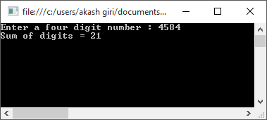

***_____________________________________________________________________________________***

***PROGRAM 8:***

Write a program to swap the values of two variables using Call by Reference.

***CODE:***

using System;

using System.Collections.Generic;

using System.Linq;

using System.Text;

using System.Threading.Tasks;

namespace Assignment1_8

{

class Variable

{

public int a, b;

}

class Program

{

static void Main(string[] args)

{

Variable ob = new Variable();

Console.Write("Enter the value for a :");

ob.a=Convert.ToInt16(Console.ReadLine());

Console.Write("Enter the value for b :");

ob.b = Convert.ToInt16(Console.ReadLine());

Console.WriteLine("Value for a before change :"+ob.a);

Console.WriteLine("Value for b before change :" +ob.b);

new Program().swap(ob);

Console.WriteLine("Value for a after change :" + ob.a);

Console.WriteLine("Value for b after change :" + ob.b);

Console.ReadLine();

}

private void swap(Variable ob)

{

int temp;

temp = ob.a;

ob.a = ob.b;

ob.b = temp;

}

}

}

***OUTPUT:***

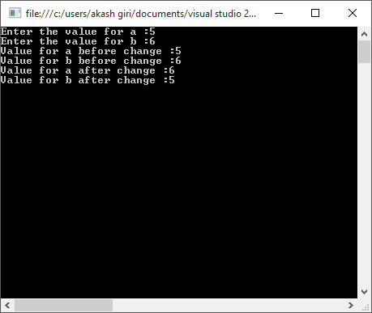

***PROGRAM 9:***

Write a program to calculate the sum of first digit and last digit of a given number

***CODE:***

using System;

using System.Collections.Generic;

using System.Linq;

using System.Text;

using System.Threading.Tasks;

namespace Assignment1_9

{

class Program

{

static void Main(string[] args)

{

Console.Write("Enter a number :");

int n = Convert.ToInt32(Console.ReadLine());

int sum = 0, x, m;

m=n;

while(n>0)

{

x = n % 10;

if (n == m)

sum += x;

n /= 10;

if (n == 0)

sum += x;

}

Console.WriteLine("Sum of first and last digit is " + sum);

Console.ReadLine();

}

}

}

***OUTPUT:***

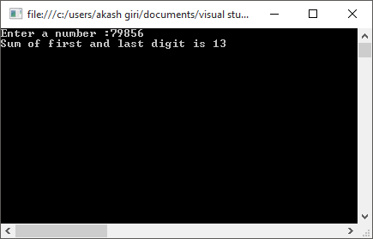

***_____________________________________________________________________________________***

***PROGRAM 10:***

Write a program to accept a string from user , delete all vowels from the string and display the result.

***CODE:***

using System;

using System.Collections.Generic;

using System.Linq;

using System.Text;

using System.Threading.Tasks;

namespace Assignment1_10

{

class Program

{

static void Main(string[] args)

{

Console.Write("Enter a string : ");

string s = Console.ReadLine();

int f = 0,i;

char[] str = s.ToCharArray();

for (i = 0; i < str.Length;i++ )

{

if ("aeiouAEIOU".Contains(str[i]))

{

for (int j = i; j < str.Length - 1; j++)

str[j] = str[j + 1];

str[str.Length - f - 1] = '\0';

f++;

}

}

string res = new string(str);

Console.WriteLine("Manipulated String : " + res);

Console.ReadLine();

}

}

}

***OUTPUT:***

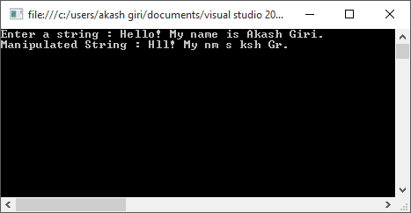

***PROGRAM 11:***

Write a program to accept a string value from the user and accept a char value from the user and and find out the total occurrence of char value in the string value.

***CODE:***

using System;

using System.Collections.Generic;

using System.Linq;

using System.Text;

using System.Threading.Tasks;

namespace Assignment1_11

{

class Program

{

static void Main(string[] args)

{

Console.Write("Enter a string : ");

String s = Console.ReadLine();

Console.Write("Enter the character to be searched : ");

char c = Convert.ToChar(Console.ReadLine());

int f = 0;

foreach(char x in s)

{

if (c == x)

f++;

}

Console.WriteLine("Frequency of " + c + " = " + f);

Console.ReadLine();

}

}

}

***OUTPUT:***

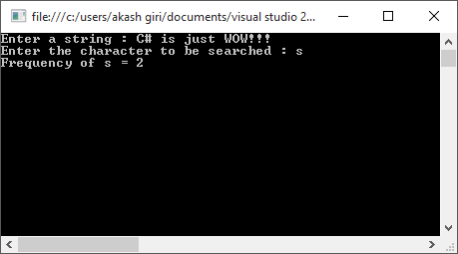

***PROGRAM 12:***

Write a program to accept a sentence from the user and reverse its each word.

***CODE:***

using System;

using System.Collections.Generic;

using System.Linq;

using System.Text;

using System.Threading.Tasks;

namespace Assignment12

{

class Program

{

static void Main(string[] args)

{

Console.Write("Enter a sentence : ");

string s = Console.ReadLine();

string[] words=s.Split(' ');

Console.Write("Reversed word : ");

for (int i = words.Length - 1; i >= 0; i--)

Console.Write(words[i] + " ");

Console.ReadLine();

}

}

}

***OUTPUT:***

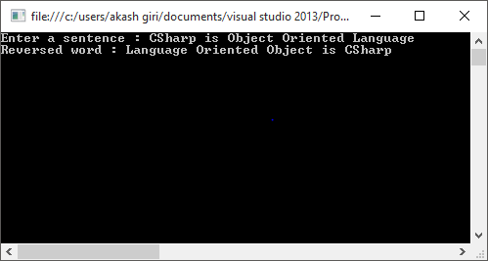

***PROGRAM 13:***

Write a program to calculate sum of elements of M*N matrix.

***CODE:***

using System;

using System.Collections.Generic;

using System.Linq;

using System.Text;

using System.Threading.Tasks;

namespace Assignment1_13

{

class Program

{

static void Main(string[] args)

{

Console.Write("Enter the no. of Rows : ");

int m = Convert.ToInt32(Console.ReadLine());

Console.Write("Enter the no. of Column : ");

int n = Convert.ToInt32(Console.ReadLine());

int[,] ar = new int[m,n];

int i, j, sum = 0;

for(i=0;i<m;i++)

{

for(j=0;j<n;j++)

{

Console.Write("Enter the element : ");

ar[i, j] = Convert.ToInt32(Console.ReadLine());

sum += ar[i, j];

}

}

Console.WriteLine("Sum of the elements = " + sum);

Console.ReadLine();

}

}

}

***OUTPUT:***

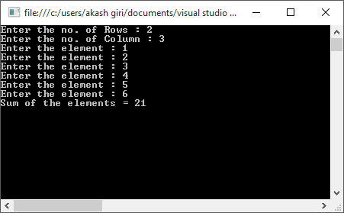

***PROGRAM 14:***

Write a program to accept ‘n’ numbers from user and store these numbers into an array and count the number of occurrences of each number.

***CODE:***

using System;

using System.Collections.Generic;

using System.Linq;

using System.Text;

using System.Threading.Tasks;

namespace Assignment1_14

{

class Program

{

static void Main(string[] args)

{

Console.Write("Enter the length of array : ");

int n = Convert.ToInt32(Console.ReadLine());

int[] ar = new int[n];

int i, j, t, f;

for(i=0;i<ar.Length;i++)

{

Console.Write("enter the element : ");

ar[i] = Convert.ToInt32(Console.ReadLine());

}

for(i=0;i<ar.Length-1;i++)

{

for(j=0;j<ar.Length-i-1;j++)

{

if(ar[j]>ar[j+1])

{

t = ar[j];

ar[j] = ar[j + 1];

ar[j + 1] = t;

}

}

}

for (i = 0; i < ar.Length; i++)

{

f = 1;

for (j = i + 1; j <= ar.Length - 1; j++)

{

if (ar[i] == ar[j] && ar[i] != '\0')

{

f++;

ar[j] = '\0';

}

}

if (ar[i] != '\0')

{

Console.WriteLine("Frequency of " + ar[i] + " is " + f);

}

}

Console.ReadLine();

}

}

}

***OUTPUT:***

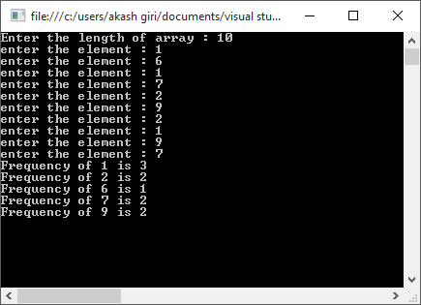

***PROGRAM 15:***

Write a program to calculate X(Y+Z) .

***CODE:***

using System;

using System.Collections.Generic;

using System.Linq;

using System.Text;

using System.Threading.Tasks;

namespace Assignment1_15

{

class Program

{

static void Main(string[] args)

{

Console.Write("Enter the value of x : ");

int x = Convert.ToInt32(Console.ReadLine());

Console.Write("Enter the value of y : ");

int y = Convert.ToInt32(Console.ReadLine());

Console.Write("Enter the value of z : ");

int z = Convert.ToInt32(Console.ReadLine());

Console.WriteLine("{0}^{1} = {2:N0}",x,y+z

,(long)Math.Pow(x, (y + z)));

Console.ReadLine();

}

}

}

***OUTPUT:***

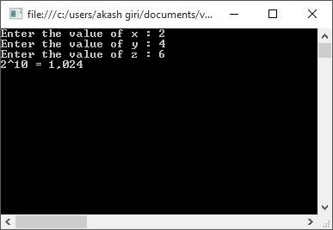

***PROGRAM 16:***

Write a Program to Accept character and display its Ascii value and its Next and Previous Character.

***CODE:***

using System;

using System.Collections.Generic;

using System.Linq;

using System.Text;

using System.Threading.Tasks;

namespace Assignment1_16

{

class Program

{

static void Main(string[] args)

{

Console.Write("Enter the character : ");

char ch = Convert.ToChar(Console.ReadLine());

Console.WriteLine("ASCII value of " + ch + " is " + (int)ch);

Console.WriteLine("Successor of " + ch + " is " + (char)(ch+1));

Console.WriteLine("Predecessor of " + ch + " is " + (char)(ch-1));

Console.ReadLine();

}

}

}

***OUTPUT:***

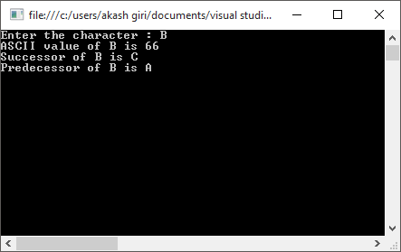

***PROGRAM 17:***

Write a Program to accept ‘n’ numbers and store all prime numbers in an array and display the array.

***CODE:***

using System;

using System.Collections.Generic;

using System.Linq;

using System.Text;

using System.Threading.Tasks;

namespace Assignment1_18

{

class Program

{

static void Main(string[] args)

{

int k = 0;

Console.Write("Enter the number of entries : ");

int n = Convert.ToInt32(Console.ReadLine());

int[] ar = new int[n];

for(int i=0;i<n;i++)

{

Console.Write("Enter the number : ");

int x = Convert.ToInt32(Console.ReadLine());

if(checkPrime(x))

ar[k++] = x;

}

Console.WriteLine("Prime numbers are : ");

foreach (int a in ar)

{

if (a != 0)

Console.Write(a + " ");

}

Console.ReadLine();

}

private static bool checkPrime(int x)

{

int f = 0;

for(int i=2;i<x;i++)

{

if(x%i==0)

{

f++;

break;

}

}

if (f == 0)

return true;

else

return false;

}

}

}

***OUTPUT:***

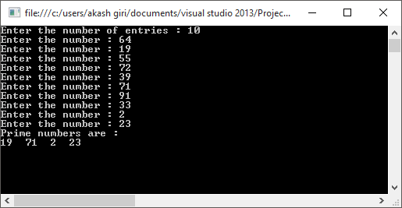

***PROGRAM 18:***

Write a program to calculate the x to the power y without using Standard functions.

***CODE:***

using System;

using System.Collections.Generic;

using System.Linq;

using System.Text;

using System.Threading.Tasks;

namespace Assignment1_19

{

class Program

{

static void Main(string[] args)

{

Console.Write("Enter the Base : ");

int x = Convert.ToInt32(Console.ReadLine());

Console.Write("Enter the Indices : ");

int y = Convert.ToInt32(Console.ReadLine());

long z = 1;

for (int i = 0; i < y; i++)

z *= (long)x;

Console.WriteLine("{0}^{1}={2:N0}", x, y, z);

Console.ReadLine();

}

}

}

***OUTPUT:***

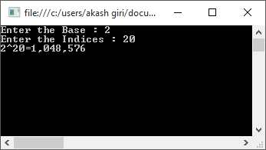

***PROGRAM 19:***

Write a program to accept three sides of a triangle as input and print whether the Triangle is valid or Not.

(The triangle is valid, if sum of each of the two sides is greater than the third side.)

***CODE:***

using System;

using System.Collections.Generic;

using System.Linq;

using System.Text;

using System.Threading.Tasks;

namespace Assignment1_17

{

class Program

{

static void Main(string[] args)

{

Console.Write("Enter the first side : ");

int a = Convert.ToInt32(Console.ReadLine());

Console.Write("Enter the second side : ");

int b = Convert.ToInt32(Console.ReadLine());

Console.Write("Enter the third side :");

int c = Convert.ToInt32(Console.ReadLine());

if (new Program().checkValidity(a, b, c))

Console.WriteLine("Triangle of given side is Valid");

else

Console.WriteLine("Triangle of given side is not valid");

Console.ReadLine();

}

private bool checkValidity(int a, int b, int c)

{

if((a+b)>c && (b+c)>a && (a+c)>b)

return true;

else

return false;

}

}

}

***OUTPUT:***

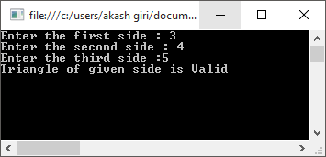

***_____________________________________________________________________________________***

***PROGRAM 20:***

Write a program to accept string from the user and replace all occurrences of character ‘a’ by ‘*’ symbol.

***CODE:***

using System;

using System.Collections.Generic;

using System.Linq;

using System.Text;

using System.Threading.Tasks;

namespace Assignment1_20

{

class Program

{

static void Main(string[] args)

{

Console.Write("Enter a string : ");

string s = Console.ReadLine();

char[] ch = s.ToCharArray();

for(int i = 0;i<ch.Length;i++)

{

if (ch[i] == 'a')

ch[i] = '*';

}

Console.WriteLine("Modified string : " + new string(ch));

Console.ReadLine();

}

}

}

***OUTPUT:***

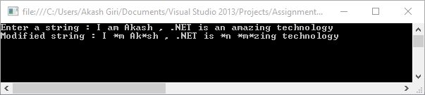

***_____________________________________________________________________________________***

***PROGRAM 21:***

Write a program to create student structure having fields roll_no, stud_name, mark1, mark2,mark3. Calculate the total and average of marks and arrange the records in descending order of marks.

***CODE:***

using System;

using System.Collections.Generic;

using System.Linq;

using System.Text;

using System.Threading.Tasks;

namespace Assignment1_21

{

struct Student

{

public string name;

public int roll, mark1, mark2, mark3;

}

class Program

{

static void Main(string[] args)

{

Student[] stu = new Student[5];

int i,j, avg1,avg2;

Student temp;

for(i=0;i<5;i++)

{

Console.WriteLine("Enter details of Student " + (i + 1));

Student s;

Console.Write("Enter name :");

s.name = Console.ReadLine();

Console.Write("Enter roll :");

s.roll = Convert.ToInt32(Console.ReadLine());

Console.Write("Enter MArk 1 :");

s.mark1 = Convert.ToInt32(Console.ReadLine());

Console.Write("Enter Mark 2 :");

s.mark2 = Convert.ToInt32(Console.ReadLine());

Console.Write("Enter Mark 3 :");

s.mark3 = Convert.ToInt32(Console.ReadLine());

stu[i] = s;

}

for(i=0;i<4;i++)

{

for(j=0;j<4-i;j++)

{

avg1=calAVG(stu[j]);

avg2 = calAVG(stu[j+1]);

if(avg1<avg2)

{

temp = stu[j];

stu[j] = stu[j + 1];

stu[j + 1] = temp;

}

}

}

Console.WriteLine("\nNAME\tROLL\tMARK 1\tMARK 2\tMARK 3\tAVERAGE");

foreach (Student a in stu)

Console.WriteLine(a.name + "\t" + a.roll + "\t" + a.mark1 + "\t" + a.mark2 + "\t" + a.mark3 + "\t" + calAVG(a));

Console.ReadLine();

}

static int calAVG(Student x)

{

return (x.mark1 + x.mark2 + x.mark3) / 3;

}

}

}

***OUTPUT:***

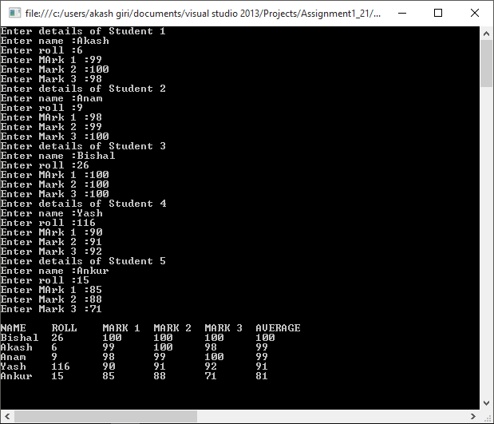

***_____________________________________________________________________________________***

***PROGRAM 22:***

Write a program to accept Book Details o f’n’ books as book_title,author, publisher and cost. Assign the accession number to each book in increasing order Display thease details as .

--Book s of a specific author

--Books by a specific publisher

--All Books costing rs 500 and above.

All Books.

***CODE:***

using System;

using System.Collections.Generic;

using System.Linq;

using System.Text;

using System.Threading.Tasks;

namespace Assignment1_22

{

public class Books

{

public string Name, Author,Publisher;

public int ISBN;

public double cost;

public void Accept()

{

Console.Write("Enter ISBN number : ");

ISBN =Convert.ToInt32(Console.ReadLine());

Console.Write("Enter Name : ");

Name = Console.ReadLine();

Console.Write("Enter Author : ");

Author = Console.ReadLine();

Console.Write("Enter Publisher : ");

Publisher = Console.ReadLine();

Console.Write("Enter Cost : ");

cost = Convert.ToDouble(Console.ReadLine());

}

public void Show()

{

Console.WriteLine("Book ISBN : " + ISBN);

Console.WriteLine("\tBook Name : " + Name);

Console.WriteLine("\tBook Author : " + Author);

Console.WriteLine("\tBook Publisher : " + Publisher);

Console.WriteLine("\tBook Cost : " + cost + "\n");

}

}

class Program

{

static Books[] ar;

static void Main(string[] args)

{

Console.Write("Enter the number of Books : ");

int n = Convert.ToInt32(Console.ReadLine());

ar = new Books[n];

int i, j;

for (i = 0; i < n;i++)

{

Console.WriteLine("Details of Book " + (i + 1));

Books ob = new Books();

ob.Accept();

ar[i] = ob;

}

new Program().sortBooks(n);

Console.WriteLine("\nPress 1 to Display Book Information by Given Author");

Console.WriteLine("Press 2 to Display Book Information by Given Publisher");

Console.WriteLine("Press 3 to Display All Books of cost less than Rs.500");

Console.WriteLine("Press 4 Display All Books");

Console.WriteLine("Press 5 to Exit\n");

int ch;

do

{

Console.Write("Enter Your Choice : ");

ch = Convert.ToInt32(Console.ReadLine());

switch (ch)

{

case 1:

if (ar.Count() == 0)

Console.WriteLine("Library is empty!!\n");

else

{

Console.Write("Enter the Book's Author :");

string auth = Console.ReadLine();

foreach (Books b in ar)

{

if (b.Author == auth)

b.Show();

}

}

break;

case 2:

if (ar.Count() == 0)

Console.WriteLine("Library is empty!!\n");

else

{

Console.Write("Enter the Book's Publiser :");

string pub = Console.ReadLine();

foreach (Books b in ar)

{

if (b.Publisher == pub)

b.Show();

}

}

break;

case 3:

Console.WriteLine("Number of books of cost less than Rs.500");

if (ar.Count() == 0)

Console.WriteLine("Library is empty!!\n");

else

{

foreach (Books b in ar)

{

if (b.cost<500)

b.Show();

}

}

break;

case 4:

if (ar.Count() == 0)

Console.WriteLine("Library is empty!!\n");

else

{

Console.WriteLine("ISBN\tNAME\tAUTHOR\tPUBLISHER\tCOST");

foreach (Books b in ar)

b.Show();

}

break;

default:

Console.WriteLine("Ooopsss!! Invalid Input. Try again.");

break;

}

} while (ch != 5);

}

private void sortBooks(int n)

{

int i, j;

Books temp;

for(i=0;i<n-1;i++)

{

for(j=0;j<n-i-1;j++)

{

if(ar[j].ISBN>ar[j+1].ISBN)

{

temp = ar[j];

ar[j] = ar[j + 1];

ar[j+1]=temp;

}

}

}

}

}

}

***OUTPUT:***

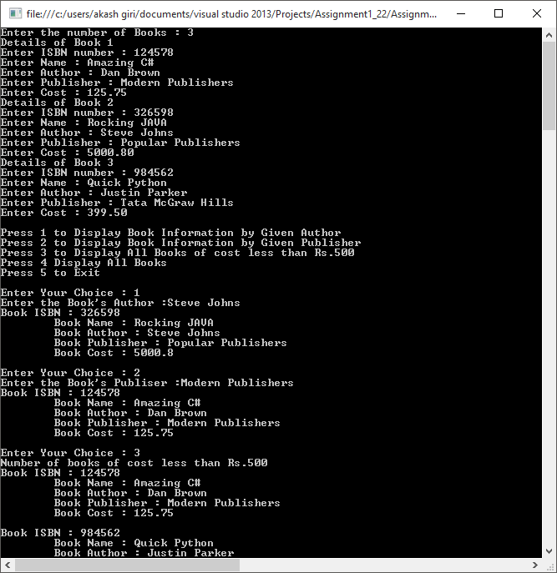

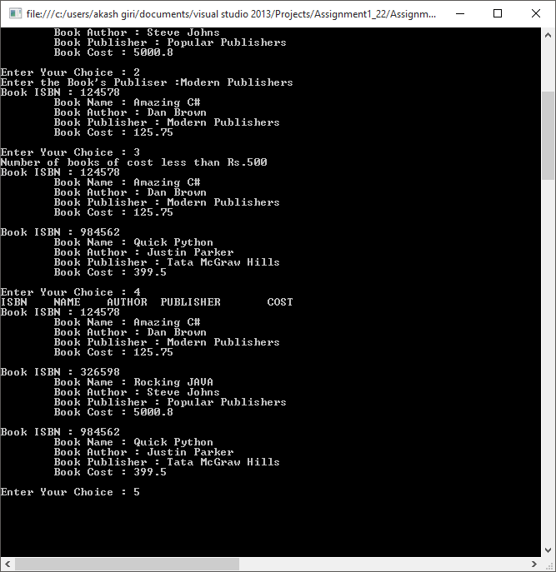

***_____________________________________________________________________________________***

***PROGRAM 23:***

Write a menu driven program in to perform the following operations on string using standard library functions

--Calculate length of string

--Reverse a given string

--Concatenation of one string to another

--Copy one String into another

--Compare two string.

***CODE:***

using System;

using System.Collections.Generic;

using System.Linq;

using System.Text;

using System.Threading.Tasks;

namespace Assingment1_23

{

class Program

{

static void Main(string[] args)

{

Console.Write("Enter the string : ");

string s = Console.ReadLine(),r;

int ch;

Console.WriteLine("\nPress 1 to calculate length of string ");

Console.WriteLine("Press 2 to reverse a string");

Console.WriteLine("Press 3 to concatenating with another string");

Console.WriteLine("Press 4 to copy one string to another");

Console.WriteLine("Press 5 to compare two string");

Console.WriteLine("Press 6 to exit");

do

{

Console.Write("Enter the choice : ");

ch = Convert.ToInt32(Console.ReadLine());

if (ch == 1)

Console.WriteLine("Lenghth of string " + s.Length);

else

if (ch == 2)

{

r = s;

char[] charArray = r.ToCharArray();

Array.Reverse( charArray );

Console.WriteLine("Reverse of string " + new string(charArray));

}

else

if (ch == 3)

{

Console.Write("Enter another string : ");

r = Console.ReadLine();

Console.WriteLine("Concatenated string " + String.Concat(s, r));

}

else

if (ch == 4)

{

string x=string.Copy(s);

Console.WriteLine("Copy of string " + x);

}

else

if (ch == 5)

{

Console.Write("Enter another string : ");

r = Console.ReadLine();

Console.WriteLine("Comparing two " + s.CompareTo(r));

}

else

Console.WriteLine("Wrong choice!! Try again");

} while (ch != 6);

}

}

}

***OUTPUT:***

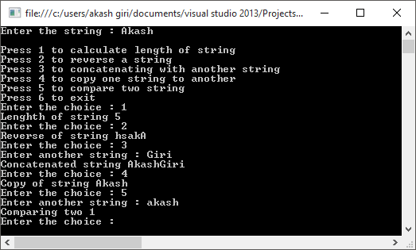

***____________________________________________________________________________________***

***PROGRAM 24:***

Write a program to display the multiplication table of a given number.

***CODE:***

using System;

using System.Collections.Generic;

using System.Linq;

using System.Text;

using System.Threading.Tasks;

namespace Assignment1_24

{

class Program

{

static void Main(string[] args)

{

Console.Write("Enter the number : ");

int x = Convert.ToInt32(Console.ReadLine());

for(int i=1;i<=10;i++)

Console.WriteLine(x + " x " + i + " = " + (x * i));

Console.ReadLine();

}

}

}

***OUTPUT:***

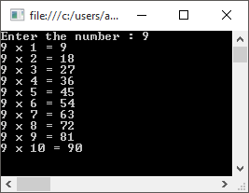

***_____________________________________________________________________________________PROGRAM 25:***

Write a program to display whether the input character is a digit or alphabet.

***CODE:***

using System;

using System.Collections.Generic;

using System.Linq;

using System.Text;

using System.Threading.Tasks;

namespace Assignment1_25

{

class Program

{

static void Main(string[] args)

{

Console.Write("Enter the Character : ");

char c = Convert.ToChar(Console.ReadLine());

if (c >= 65 && c <= 90 || c >= 97 && c <= 122)

Console.WriteLine("It is alphabet");

else

if(c>=48 &&c<=57)

Console.WriteLine("It is digit");

else

Console.WriteLine("It is special character");

Console.ReadLine();

}

}

}

***OUTPUT:***

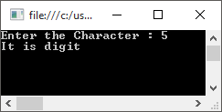

***PROGRAM 26:***

Write a program to accept basic salary from user. If basic salary>=5000 then hra=15% and da=150% of basic salary.

If basic salary<5000 then hra=10% and da=110% of basic salary .

Display the Gross salary.

***CODE:***

using System;

using System.Collections.Generic;

using System.Linq;

using System.Text;

using System.Threading.Tasks;

namespace Assignment1_26

{

class Program

{

static void Main(string[] args)

{

Console.Write("Enter the Basic Salary : ");

double b = Convert.ToDouble(Console.ReadLine()),gross;

if (b >= 5000)

gross = b + (b * 0.15) + (b * 1.5);

else

gross = b + (b * 0.1) + (b * 1.1);

Console.WriteLine("Gross Salaray = " + gross);

Console.ReadLine();

}

}

}

***OUTPUT:***

